

December 22, 2017

EE – January 2018 Product Picks

By: Evaluation Engineering

Rectifier controller with reverse protection
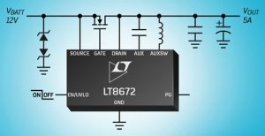
The LT8672, an active rectifier controller with reverse input protection to -40 V, features a 3-V to 42-V input voltage, making it suitable for automotive applications that must regulate through cold-crank and stop-start scenarios with minimum input voltages as low as 3.0 V and load-dump transients up to 40 V. The LT8672 drives an external N-channel MOSFET, offering a 20-mV drop, reducing power dissipation by 90%, compared to a Schottky diode, eliminating requirements for a heat sink. The fast transient response enables it to meet automotive applications requiring AC input ripple rectification up to 100 kHz. Additionally, its 20-µA quiescent current while operating, and 3.5-µA in shutdown, are suitable for always-on systems. The combination of the MSOP-10 package and external MOSFET ensures a compact solution footprint. The LT8672’s solution offers the combination of 3-V minimum output capability and a 20-mV drop, enabling it to ease the minimum input voltage requirement during cold-crank and stop-start, providing simpler and more efficient circuits. If the input power source fails or is shorted, a fast turn-off minimizes the reverse-current transients. Also, a power-good pin signals when the external MOSFET is ready to take load current. Analog Devices

Extreme-temperature socket
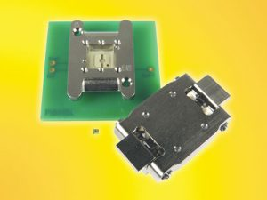
The CBT-QFN-7056 contactor employs a stamped spring pin configuration with a 14.5-g actuation force per pin and cycle life of 50,000 insertions. The self-inductance of the contactor is 0.98 nH, insertion loss is < 1 dB at 31.7 GHz, and capacitance is 0.067 pF. The current capacity of each contactor is 2 A. Socket temperature range is -55°C to +180°C.
The socket also features an IC guide for precise QFN edge alignment. The specific configuration of the package to be tested in the CBT-QFN-7056 is a DFN with 1.7×1.2-mm body size and 0.5-mm pitch. To use, drop the IC into the socket and close the removable lid by latching. Vertical force is applied by the integrated compression springs between the socket lid and compression plate. This socket can be used for hand test, screening, and custom burn-in applications with the most stringent requirements. Ironwood Electronics

Automated switching unit
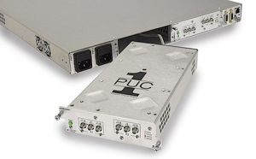
The UC1 switch system provides a modular solution for a variety of signals up to 40 GHz and is designed for smaller requirements. This product delivers high signal performance coupled with advanced remote/manual control and monitoring with 10/100 LXI-certified Ethernet port, multiserial port, front-panel control, direct alarm input port, and auto-sense (on some PUCs). The unit comes with rack-mount flanges, but also has rubber feet for benchtop use, and it includes a cable restraint bracket as well. The unit can provide redundancy switching, 1xN switching, as well as full matrix and other complex or custom configurations. Plug-ins are available for a variety of digital and analog signals including ASI, IF, and L-band up to 40 GHz.
Plug-ins can be mixed and matched as needed. Another UC1 feature (for additional flexibility) is that the PUCs can be removed from the chassis and located some distance from the chassis—closer to where you need a switch function. This could be useful for running high-frequency tests on a bench or next to an analyzer. The factory offers a number of extension cables from 3 feet to 300 feet in length. The unit includes redundant power supplies with dual power inputs (AC or AC/DC). Monitored power supplies are standard with an independent and redundant design. The unit’s AC power input is designed for any international AC power source, and an optional wide-range DC power input is also available.
Universal Switching Corporation

Ionic testing system
A self-contained system, the Omegameter identifies the presence of ionic contamination on bare and assembled printed circuit boards and other electronic components, and it provides an accurate and repeatable method for determining cleanliness on location. Additionally, the Omegameter yields immediate process-control results, eliminating the need for outside laboratory testing, and it verifies proper cleanliness of surfaces prior to the application of conformal coatings or potting compounds. The system complies with industrial specifications such as ANSI/J-STD-001 and IPC-TM-650. The Omegameter SMD 650 features several enhancements to previous models. An onboard computer provides software operation.
Software monitors and records the solution temperature, replacing the need to manually measure the temperature with a thermometer. A step-down feature lowers the test cell, making it easier to load parts. Numerous software features support unlimited test profiles with custom names, runtime contamination graphs, sort/filter/review historical test results, and more. Specialty Coating Systems
New version of test software suite
ATEasy 10 is the latest evolutionary step in the test software suite, first released in 1991 and currently deployed in test and measurement applications worldwide. ATEasy provides test engineers with the necessary tools to efficiently develop, debug, document, maintain, and execute test applications. The latest version delivers faster run-times (up to 10x faster in benchmarked tests), new integrated user collaboration tools such as ATEasy Merge, .Net Controls support, the ability to embed ATEasy run-time executables, a test-log template that provides the ability to analyze test results, and backward compatibility with all previous versions. Developed from the ground up as ATE software for test and measurement applications, ATEasy is the only commercially-available test development/test executive software with an integrated HAL (hardware abstraction layer) and full simulation capabilities, the company reports. Preserving test program development investment, ATEasy offers backward source and execution compatibility with all previous versions. ATEasy is suitable for companies with large and/or complex automated test applications, as well as system builders and/or integrators of multiple systems that require the flexibility, customizability, and the complete set of tools included with ATEasy. Marvin Test Solutions Inc.
Intelligent signal-scanning recorder
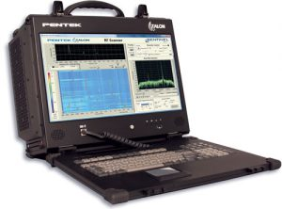
The new RTR 2613 combines intelligent signal-scanning software with real-time recording in a lightweight, portable, and rugged package. The RTR 2613 allows SIGINT engineers to scan the 3-GHz spectrum for signals of interest and monitor or record instantaneous bandwidths up to 40 MHz, once a signal of interest is detected. The RTR 2613 is housed in a rugged, lightweight chassis measuring 16.0” x 6.9” x 13.0” and typically weighs less than 30 lbs. This briefcase-style portable workstation features 100% aluminum alloy construction, reinforced with shock-absorbing rubber corners, and an impact-resistant protective glass for the 17” high-resolution LCD monitor. The RTR 2613 recorder is a grab-and-go recorder suitable for test and measurement, mobile military, security, and government intelligence (SIGINT, COMINT, and ELINT) applications. A Model 78621 Cobalt software radio module serves as the data-acquisition engine of the Talon RTR 2613. Its 200-MHz 16-bit A/D converter provides 86 dB of spurious-free dynamic range and 75 dB of SNR. A digital downconverter (DDC) provides frequency zooming for signal bandwidths from 40 MHz to as low as a few kHz. The Model 78621 is driven by a 3-GHz RF tuner front end. The vendor’s Sentinel recorders add intelligent signal monitoring and detection capabilities to Talon real-time recording systems.
The intuitive GUI allows users to monitor the entire spectrum or select a region of interest, while a selectable resolution bandwidth allows the user to trade sweep rate for a finer resolution and better dynamic range. Scan settings can be saved as profiles for quick setup in the field. Any RF band can be selected for monitoring and real-time recording. Pentek
USB data-acquisition system
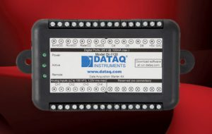
The Model DI-1120 USB data acquisition system, which the company describes as its most advanced, low-cost DAQ system, provides four differential analog inputs and seven bidirectional discrete ports. Two ports are programmable as a counter or frequency input.
The analog inputs have a programmable measurement range of ±2 to 100 V per channel and are multiplexed to a 14-bit ADC. The sample rate is programmable and can be as low as 2.2 samples per hour and as fast as 160,000 samples per second. The DI-1120’s armored analog inputs withstand voltages up to ±120 VRMS. The digital inputs are protected up to 25 V. These specs make the DI-1120 tough and resilient for demanding industrial measurements, the company said. Included is WinDaq software to allow ready-to-run data acquisition, display, playback, and analysis as well as .Net classes and ActiveX controls for programming the DI-1120 under Windows. A documented instrument protocol is also provided for operating systems. Software supports Windows 7 and higher, both 32- and 64-bit versions. DATAQ Instruments

https://www.evaluationengineering.com/ee-%E2%80%93-january-2018-product-picks

